Research Briefing

Poverty and Neighbourhood Renewal in West Cornwall
A 2001 Census Update

Professor David Gordon and Dr Eldin Fahmy

This research updates earlier analysis carried out by the University of Bristol and Cornwall Health Research Unit and published in January 2002. This earlier study made extensive use of 1991 Census data to identify priority areas for NRF funding at 1991 Census Enumeration District level. This update uses recently released 2001 Census data to identify priority areas for NRF funding based on the new Census small area geography of Output Areas. The main report focuses on:

- Identifying deprived areas - Identifying the most deprived Output Areas in West Cornwall using comparable methods to the 2002 study.

- Identifying deprived areas by Neighbourhood Renewal theme - Identifying the most deprived Output Areas in West Cornwall for each of the Neighbourhood Renewal Fund (NRF) themes: Income (Poverty), Employment, Education, Health and Housing.

Using 2001 Census and other data a weighted scale of multiple deprivation was constructed which can be used to identify small areas with priority needs. The following weighting was used:

- Poverty rate | 20%
- Child poverty rate | 20%
- Unemployment rate | 20%
- Standardised Ill Health Ratio | 12%
- No educational qualifications | 12%
- Housing Deprivation & Council Tax Band A | 8%
- Access to a car | 8%

Output Areas (OAs) were then ranked according to their score on this cumulative index. On this basis, it was possible to identify the most deprived OAs for any population threshold (in this case the 33% level). In 2002, West Cornwall Together decided that the poorest areas in West Cornwall - in which a third of the population lived - should be considered as priority areas for NRF funding.

Conclusion

A more accurate and precise analyses of priority need is now possible than could be achieved using 1991 Census data. In particular, smaller pockets of deprivation in the more rural areas of West Cornwall are now identifiable as having a priority level of need. The conclusion of this research is that the West Cornwall Local Strategic Partnership may wish to consider extending the priority areas eligible for NRF funding to include Carharrack, Lanner, Ponsanooth, Stithians, Four Lanes, Mabe Burnthouse, Mawnan Smith, Ludgvan and Germoe. All these areas can now be shown to have a priority level of need based upon ‘objective’ scientific criteria (see map overleaf).

Priority Areas at the 33% Population Threshold, 2001 Census

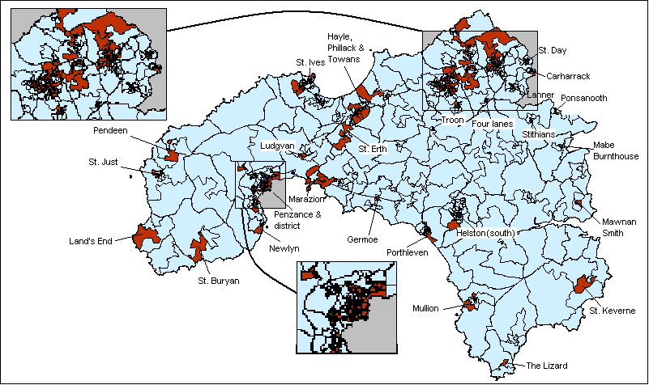

Cemlyn, S., Fahmy, E., Gordon, D. & Bennett, S. (2002). Poverty and Neighbourhood Renewal in West Cornwall. Research Report for West Cornwall Local Strategic Partnership. [URL: www.bris.ac.uk/poverty/region.htm]

